Patient Guide for use of Nonin 9560 Pulse Oximeter

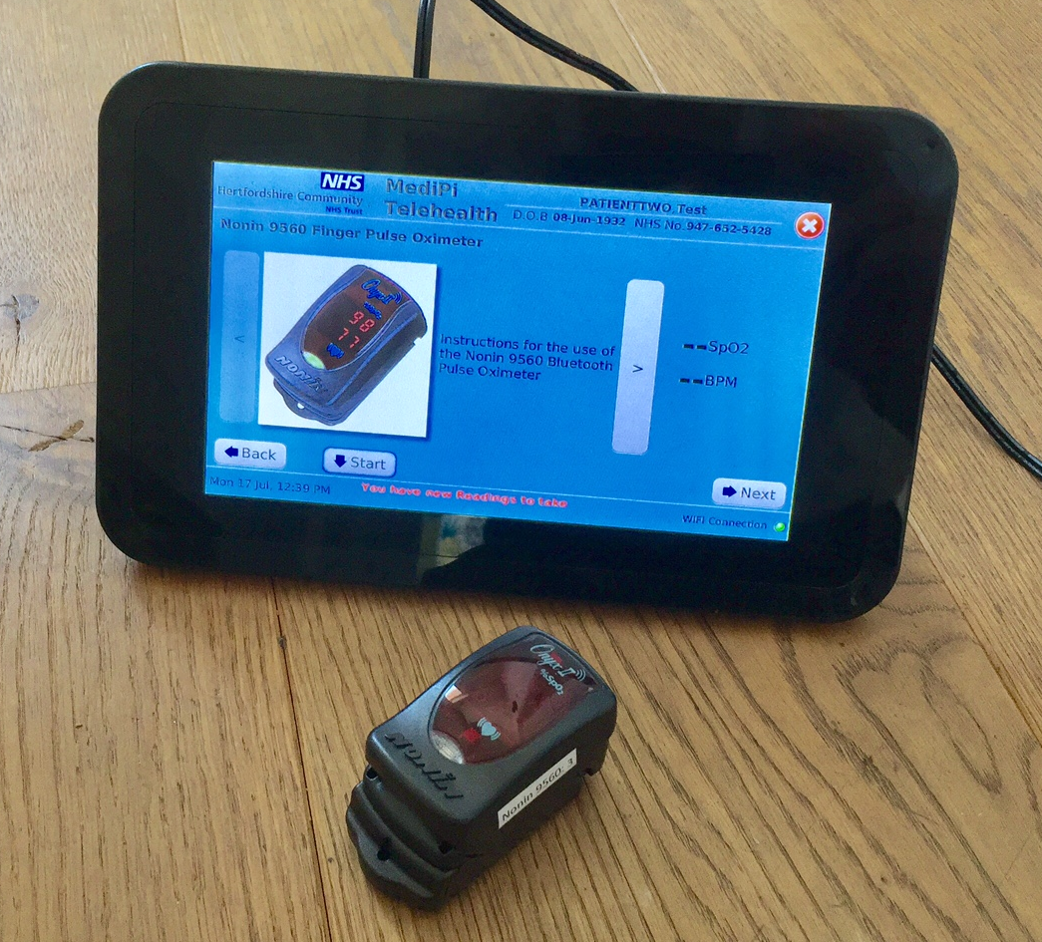

MediPi Patient Device shows opening Pulse Oximeter Screen

Nonin Pulse Oximeter is OFF

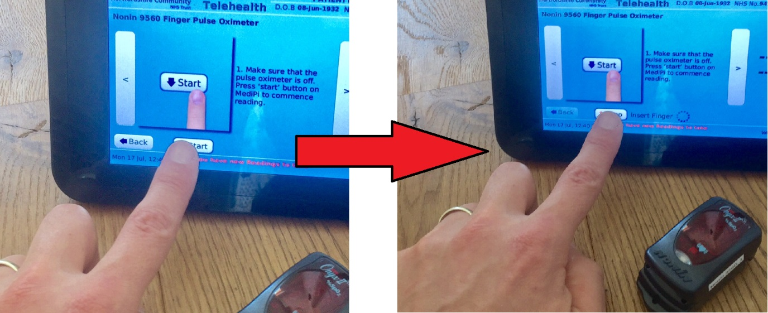

Press the on-screen “Start” button and you will be then asked to insert your finger into the Pulse Oximeter.

**Please DO NOT insert finger into the Pulse Oximeter yet!**

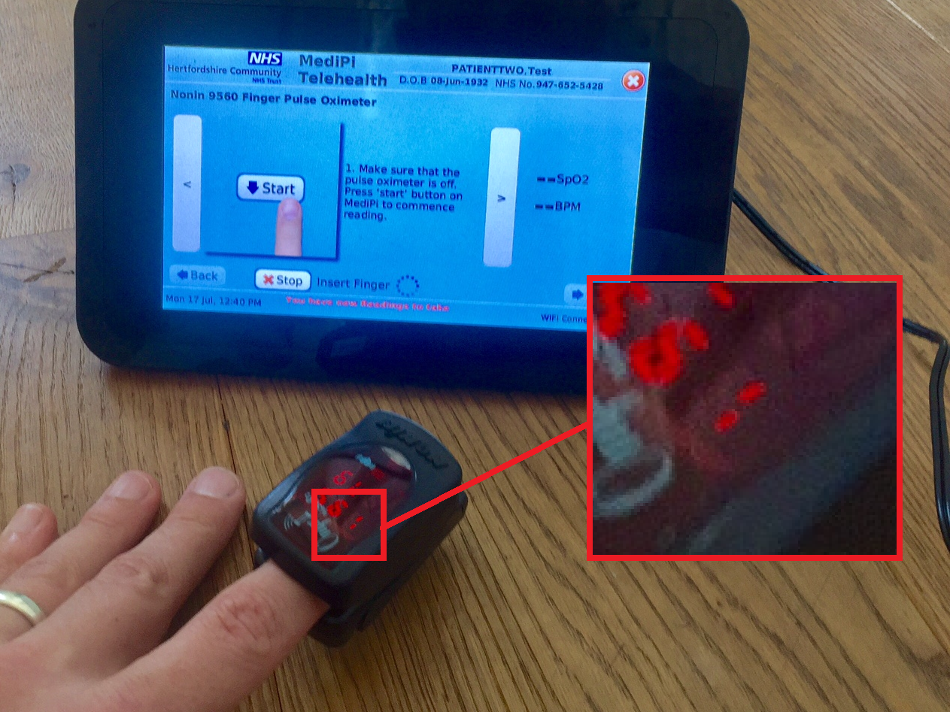

Vertical Lines Flash

If there are undownloaded results on the Pulse Oximeter, the MediPi Patient screen may display “Downloading” straight away – this is fine, just keep your finger in until the result is displayed.

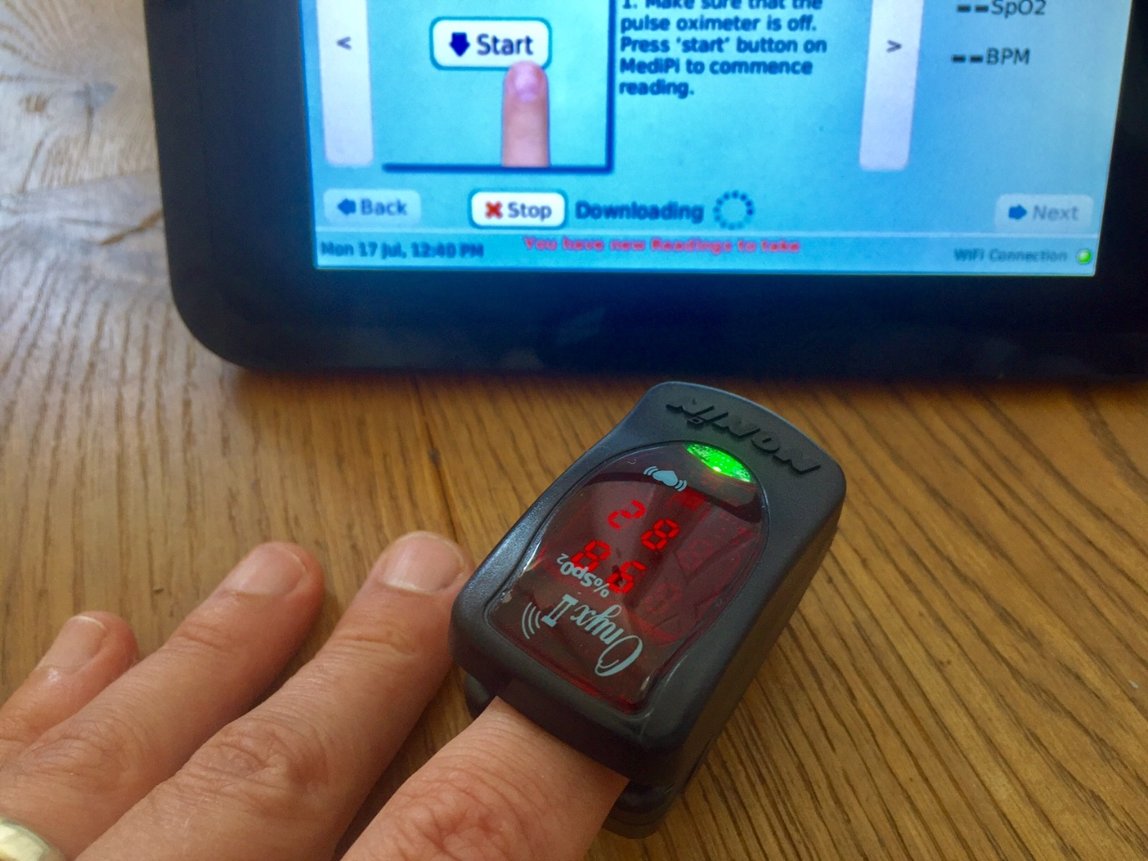

Insert your finger and observe the two vertical red lines flash until the Pulse Oximeter gets a steady reading. Do not apply any pressure to the device, just let it hang on your finger

After a short while the vertical bars will stop flashing and the device will attempt to download the data to the MediPi Patient Device. At this point the Device will display “Downloading”. Keep your finger in the Pulse Oximeter until the result appears.

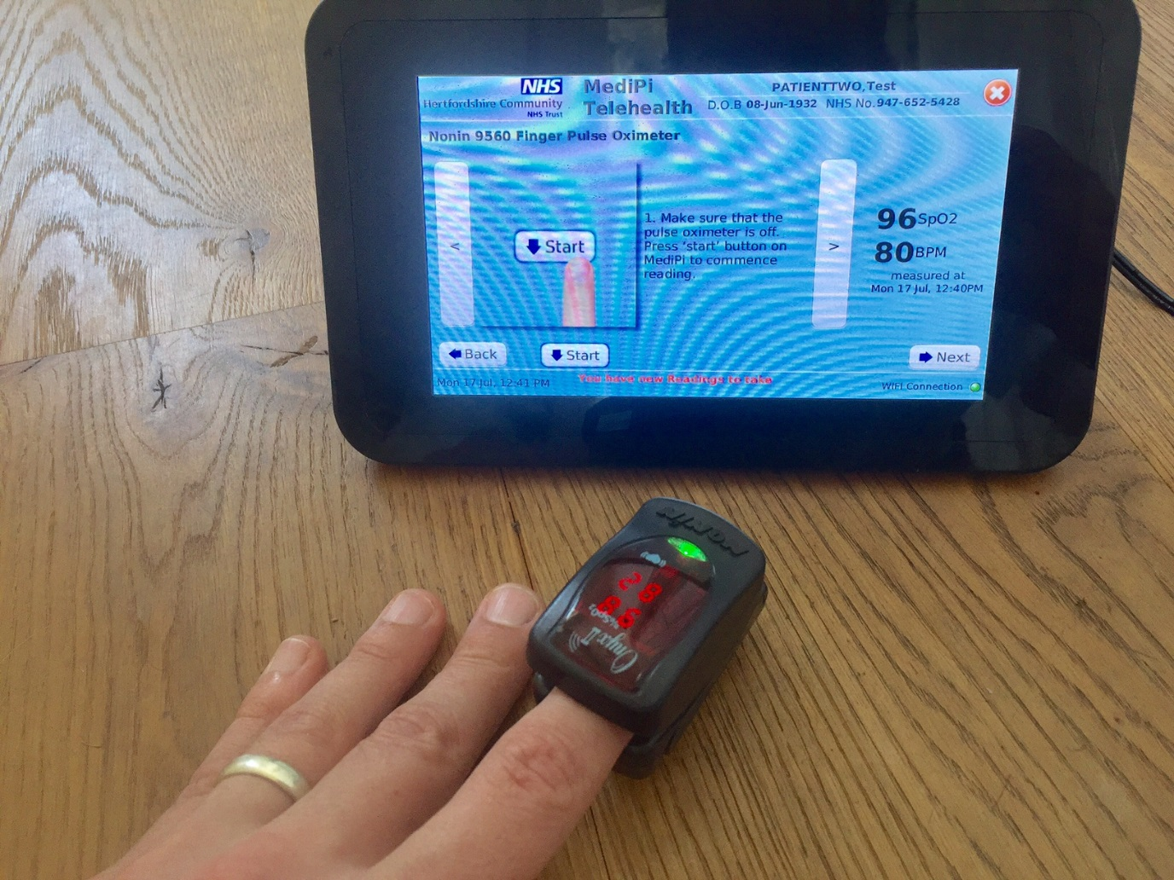

Press “Next” and continue taking your measurements

After a short while the MediPi Patient Device will display the result